**Requirements Engineering**

**Assignment 2: Advanced Requirements Modeling and Specification**

Jasinge Don Sahas Renuja Gunasekara

CUID: 20462075

Email: [20462075@student.curtin.edu.au](mailto:20462075@student.curtin.edu.au)

Date: 22/10/2021

Words: 872

Document Size: 46 Pages

Contents

Report 4

UML Class Diagram 6

Goal Modelling 8

i* Modeling 18

Strategic Dependency Model 18

Strategic Rationale Model 19

Wire Frames 20

Requirement Specification 29

1. Introduction 30

1.1 Purpose 30

1.2 Document Conventions 30

1.3 Intended Audience and Reading Suggestions 30

1.4 Project Scope 30

1.5 References 31

2. Overall Description 31

2.1 Product Perspective 31

2.2 Product Features 31

2.3 User Classes and Characteristics 31

2.4 Operating Environment 32

2.5 Design and Implementation Constraints 32

2.6 User Documentation 33

2.7 Assumptions and Dependencies 33

3. System Features 33

3.1 View Past Collaborations 33

3.2 View Ongoing Collaborations 34

3.3 View Collaborators 35

3.4 Initiate Collaborations 35

3.5 Respond to Collaboration 36

3.6 Create Chatrooms 37

3.7 Display all Chat room 38

3.8 Send/Receive Chats in the Chat room. 38

3.9 Display Branch Information 39

3.10 Edit Branch Information 40

3.11 Delete User 40

3.12 Insert New User 41

3.13 Viewing Spam Reports 41

3.14 Update User 42

4. External Interface Requirements 43

4.1 User Interfaces 43

4.2 Hardware Interfaces 43

4.3 Software Interfaces 44

4.4 Communications Interfaces 44

5. Non-Functional Requirements 44

5.1 Performance Requirements 44

5.2 Security Requirements 44

5.3 Reliability Requirements 45

5.4 Functionality Requirements 45

References 46

# Report

This report is written for the Collaboration System Case Problem to which we have drawn the UML Class Diagrams, the i* Models, the Wire frames, and finally the complete Requirement Specification Document. There were numerous issues encountered with many instances and we will go into detail on what these were.

The first issue we came across in the UML class diagram, is that I wanted the User to be either a child class of either the “National Engineers Association” or “Company” to display a difference between the Users who are part of the National Engineers Association or the Company, but however I quickly learnt that it is impossible to do so under UML 2.5 standards, where it states, “*An instance of a Classifier****is also an****(indirect)****instance of each of its generalizations****. Any Constraints applying to instances of the generalizations also apply to instances of the Classifier*”, which meant while multiple inheritance is possible, it was impossible to have conditional inheritance (Although this is possible to do in languages). One of the references I got to conditional inheritance was in [one research paper I came across](https://www.researchgate.net/publication/234578835_A_Static_C_Object-Oriented_Programming_SCOOP_Paradigm_Mixing_Benefits_of_Traditional_OOP_and_Generic_Programming), but it was “*UML-like”*, so I restructured the UML Class diagram to have “National Engineers Association” and “Company” as container classes which contains user, and the User would have an attribute which makes it easy for us to identify where the user belongs to. The second lesson learnt in the UML Class diagram is that Interface classes do not have attributes or methods but has abstract functions.

We also realized that Association Classes in UML Class Diagrams could be utilized in such a way they keep a record/track of certain interactions between methods, so I have implemented it in the UML Class Diagram as a “Log” of sorts, that keeps track of how the Admin, manipulates Users and User Roles, which will be useful in case of reversing roles as it can act as a “Stack” of sorts.

When doing further requirement elicitation, we realized that the number of concurrent collaborations happening is extremely large, so we decided to implement “Search bars” in cases where significant number of records are going to be pulled through, these are depicted in the i* diagrams but also in the Wireframes, as these search bars were extremely intuitive when it comes to searching through large datasets. There was the issue of bad accuracy of search results because of mistaken spelling since this system is to be used around the world and can be used by people whose first language may not be English. This was solved in two prongs. Existing browsers such as Chrome and Microsoft Edge already highlight mistaken spelling in text boxes which makes the entered search criteria correct. Also, if that is still inaccessible, we have the voice button, which uses Speech to Text. While this may not be exactly accurate, this still solves the problem for people who have disabilities, making the system a lot more accessible and for people who have broken keys/keyboards.

When editing branch information there was the issue of an Editor possibly entering special characters to break the code, or maliciously inject code, which was solved by removing the ability to enter special characters into the page. This is one of the places we have identified as possible for maliciously injecting the code. We learnt that some of the easiest ways to break Web Applications (especially, if it is made on PHP), is to enter certain characters that would halt that line of code, and you would be able to write your own code, however this seemed to be a bigger issue solely faced by Server-side languages.

When it comes to the creation of the Software Requirement Specification, we solely based ours on Karl E. Weigers, template that was provided to us. Throughout the sections the Software Requirement Specification eases the user into all the details about the software system being developed in multiple steps.

We initially ease the user into the Software Requirement Specification by declaring the purpose, the convention of the document and the Intended Audience, and then we draw the boundaries in which the system will be discussed afterwards in which we discuss what the software system is. We discuss all the Users, and the constraints to be faced, and delve into the features of the document. After we have declared the features of the system, we discuss how this system will interact with external interfaces. And finally, we finish the SRS document with the soft expectations of the system, the Nonfunctional Requirements.

The SRS was created in this case as a document to present all parties involved before there has been any coding laid out, as this will deal and gauge client expectations, while also giving a realistic goal to the Software Engineers and Project Managers to work towards. The scope that is defined within this SRS will be what is used when Project Managers come up with deadlines which in the end affects the quality and scope of the project. This enables the specification to be set in writing, lest the clients are able to change their view and opinion over time regarding the software system and that will cost the software development time and money.

# UML Class Diagram

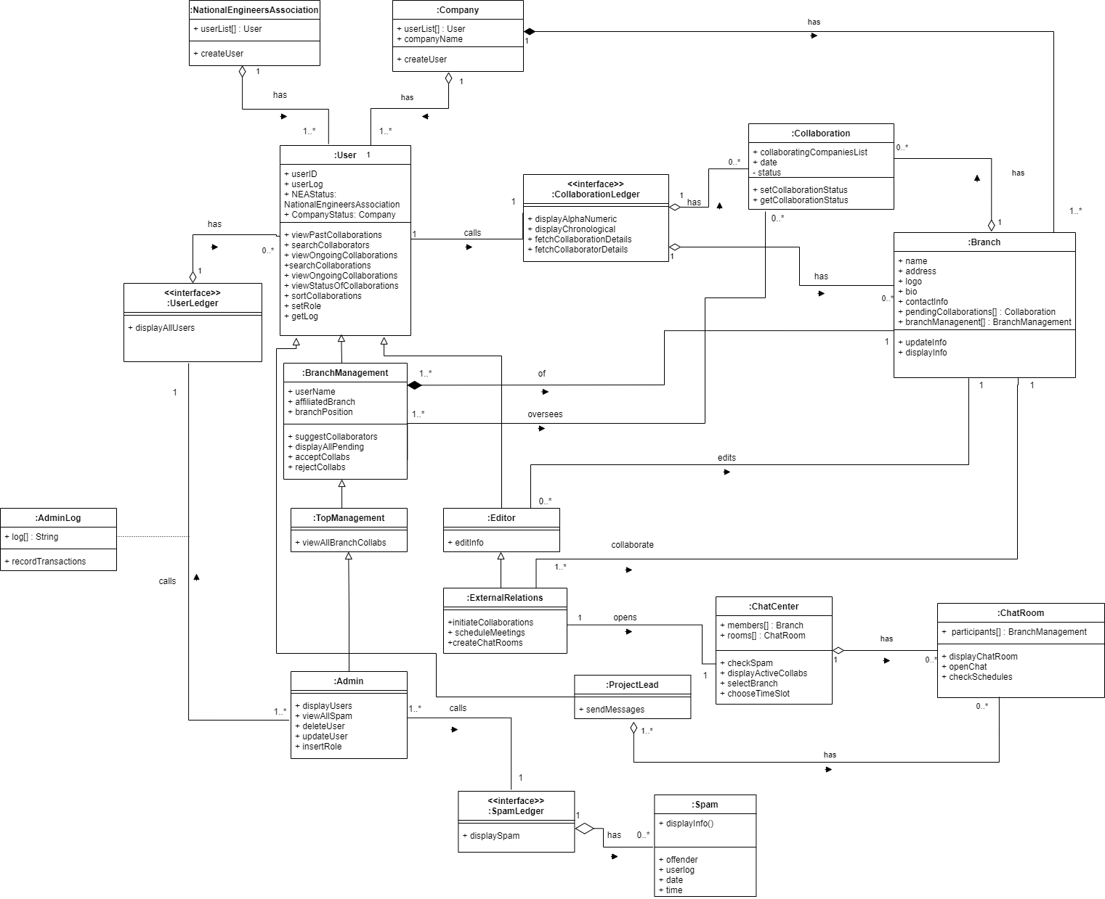

If you’re unable to view this document, please zoom as this is in PNG format and is lossless.

We have implemented Association Classes, both Aggregation and Composition and Generalization in this complete Class Diagram. Heeding to the feedback given on the first Use Case Diagram (Assignment 1) we have also attached the functionality of being able to search for Collaborators (also known as Companies/Branches of the National Engineers Association).

Assumption: National Engineers Association is a non-profit organization with branches worldwide, just like the companies that are registered on the system. Therefore, all child classes of the “User” class except the admin class is to be used by both the National Engineers Association and Companies. This makes the code much more efficient, reduces coding complexities, reduces costs, and allows the project to be completed at an earlier deadline while providing reasonable compromise of the client’s needs.

# Goal Modelling

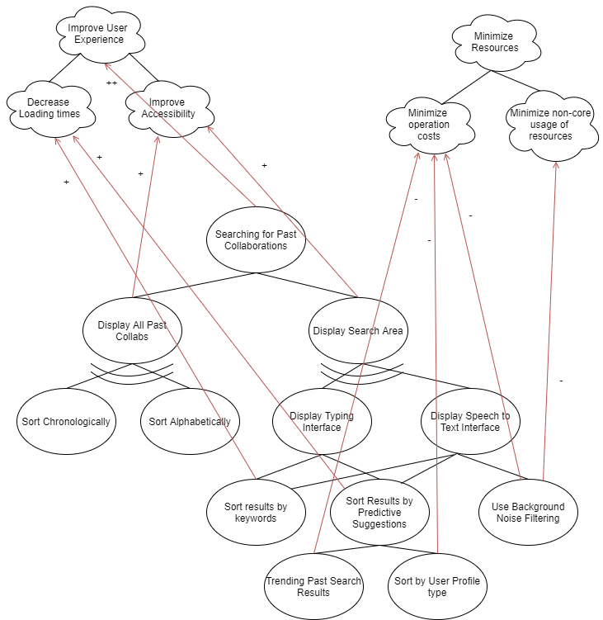

Assumption: This would use analytics for Predictive Suggestions, Trending Past Search Results, and for the Speech to Text interface. We can employ the use of plugins such as the “Google Speech to Text” and we can have analytics powered by vendors such as Amazon Web Services. Which is why it will be resource extensive and also will have a relatively high operation cost.

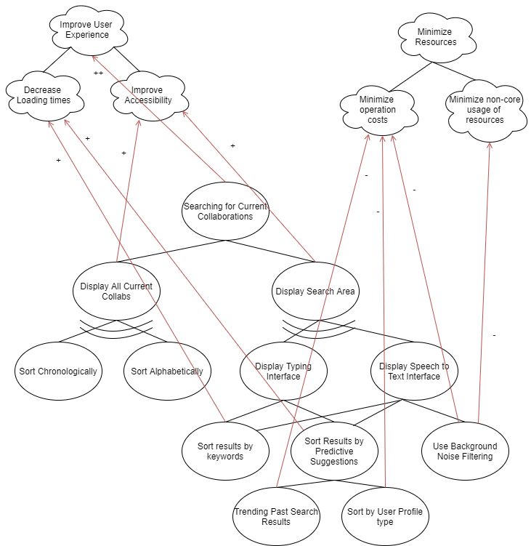

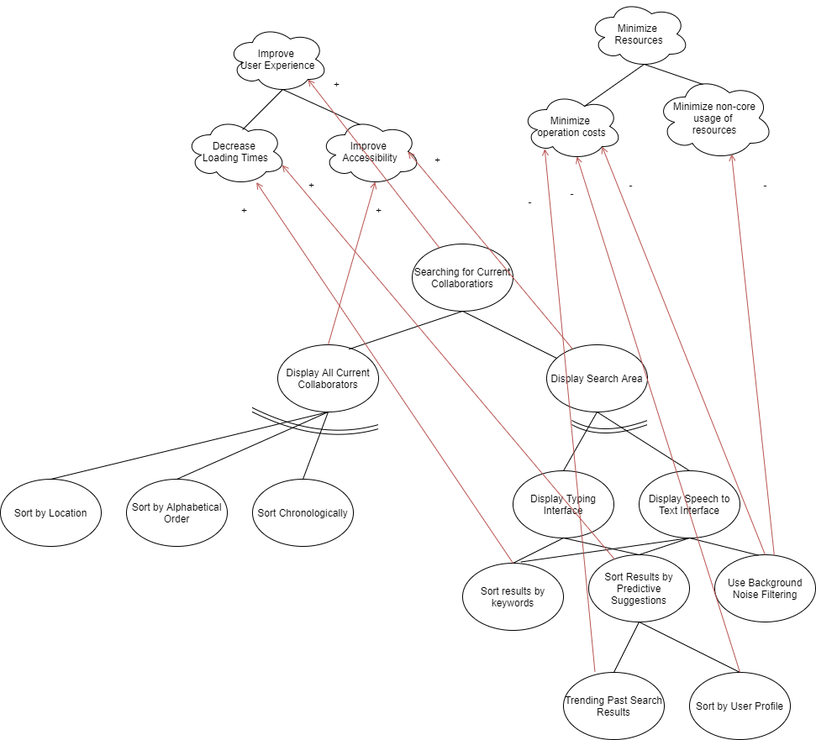

Assumption: The Match Metric system is one that is calculated within the system for how much of a “match” the suggested collaborative partnership would be. For example, if there is a company that deals with Artificial Intelligence projects, has a high accepted to rejected collaborations ratio, and is also in very close locality, it would have a match score close to 100%. A company that would be dealing in your project domain, has a very high rejection rate and is located halfway around the world would have a score close to 0%. This makes it easier for you to choose between some suggestions over the other. If there is a company that has a high match ratio, we will also send a text message to the User Role that deals with reviewal of collaborations (Top Management/Branch Management). Because they might not be on the application monitoring collaborations 24/7. This comes at the cost of invading on their personal space but is extremely accessible.

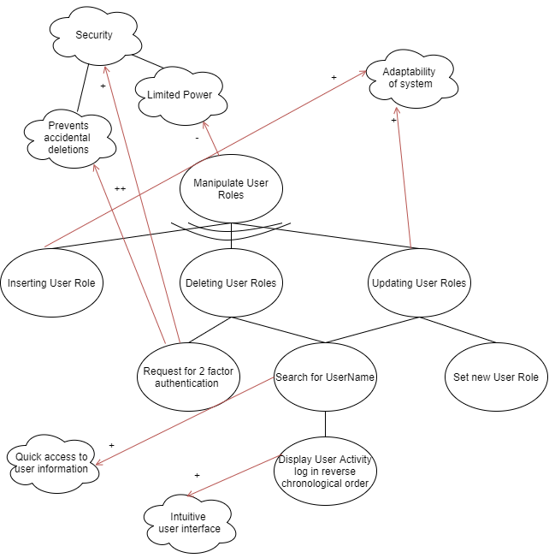

This is the goal that is being used by the Editor or Admin, to edit the Branch pages. We do not allow special characters, to prevent defacing attacks, through methods such as HTML Injection.

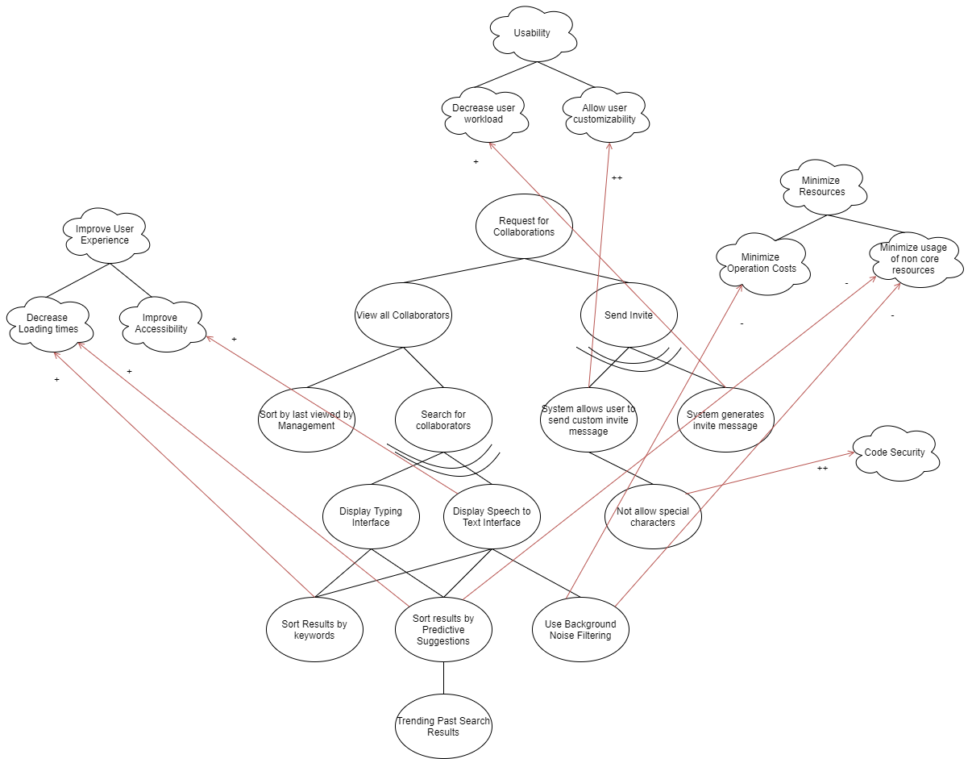

Assumption: The reason why the “View all Collaborators” goal has a subgoal “Sort by last viewed by Management” is that we asserted that it is the Management that is suggested collaborators, they request the External Relations to initiate collaborations by sending an invite. How they request is beyond our scope as there are already many existing ways to do so, eg: Verbally, by email etc. Which is why we sort by Last Viewed by Management, because it is intuitive that they will see a collaborator (Either a NEA branch or a Company) and they will request. The option to sort for it exists as well.

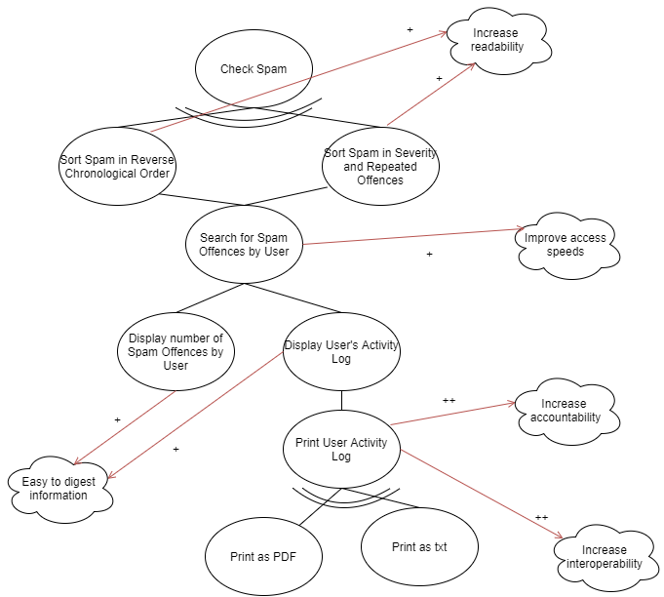

Because it is a corporate setting, once an admin bans/deletes a User for repeated spam, there may be questions asked by the management of that company that employs the user, the ability to print a log is beneficial, because then the admin can file it, and then when questioned, can present it. It makes interoperability, because it enables the system to work with the existing filing system.

Invites here refer, to Pending Collaborations, because it is an “Invite to Collaborate”.

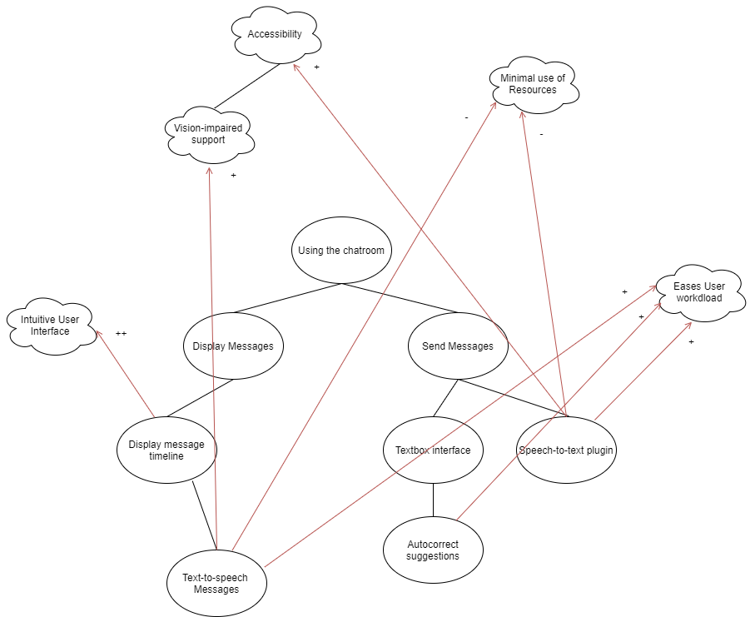

# i* Modeling

## Strategic Dependency Model

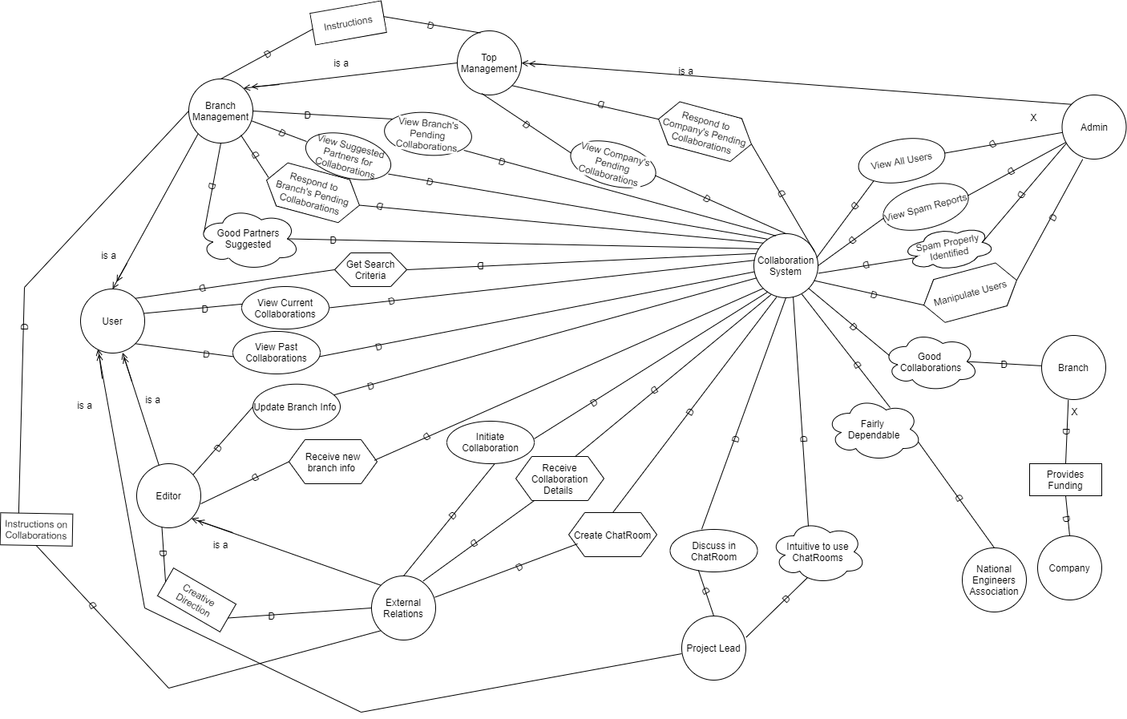

All user roles are applicable to both Company and National Engineers Association Members (except Admin), therefore there are no duplicate Actors for such. However, the National Engineers Association and Company have been mentioned, lest the diagram is incomplete.

Assumption: The Top Management, gives top-down instructions to the Branch Management on the company’s vision and direction. Companies Provide Funding at an individual branch level.

## Strategic Rationale Model

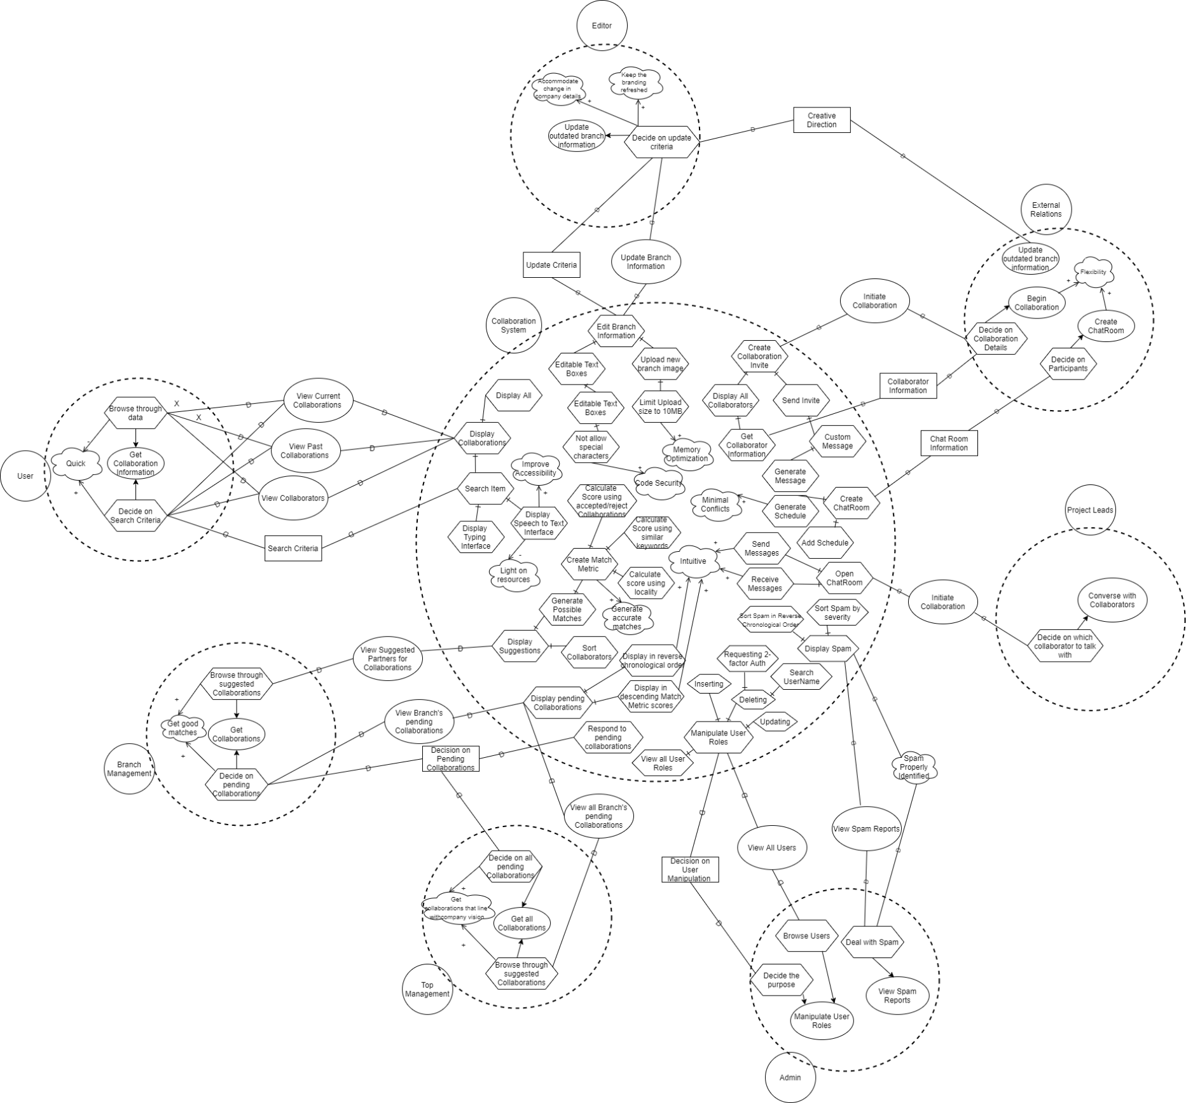

# Wire Frames

Login Page

User Role Past Collaborations Page

All Roles except User and Editor have a Dashboard section in the header. Here is a view of such. The only difference is the header.

Ongoing Collaborations

Collaborators

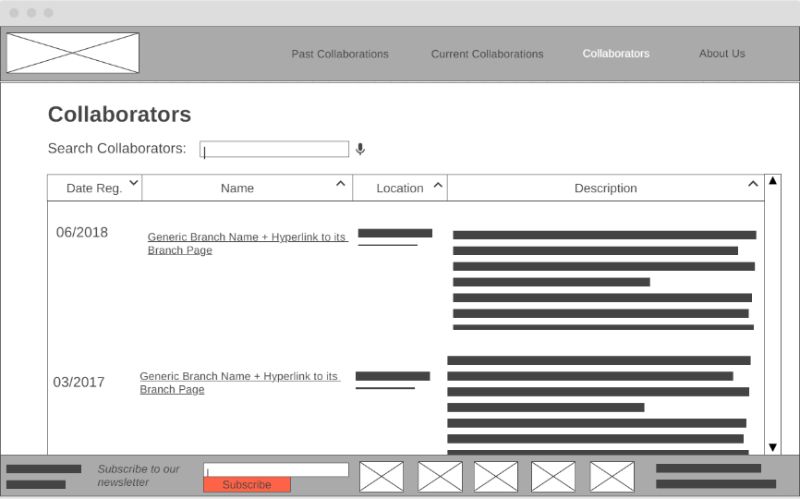

When clicking on the Name in the Collaborators section you visit the Branch Page.

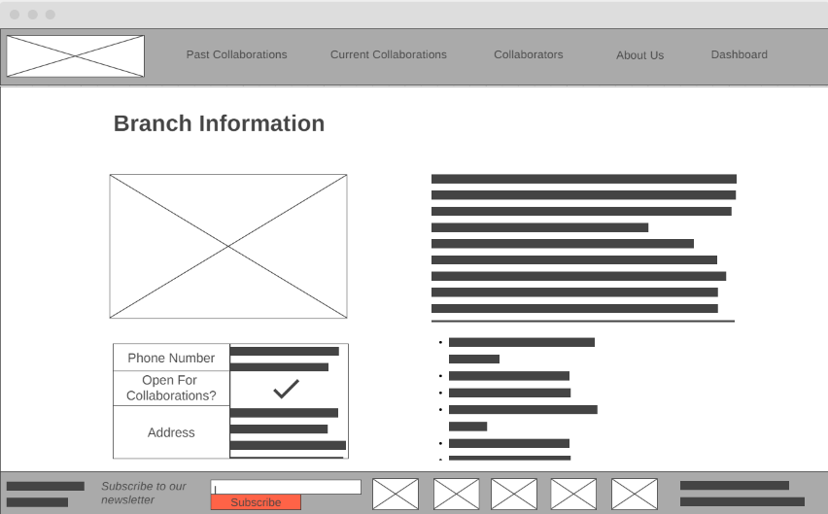

When Editors visit the Branch Page of their Employer, they see a little edit icon

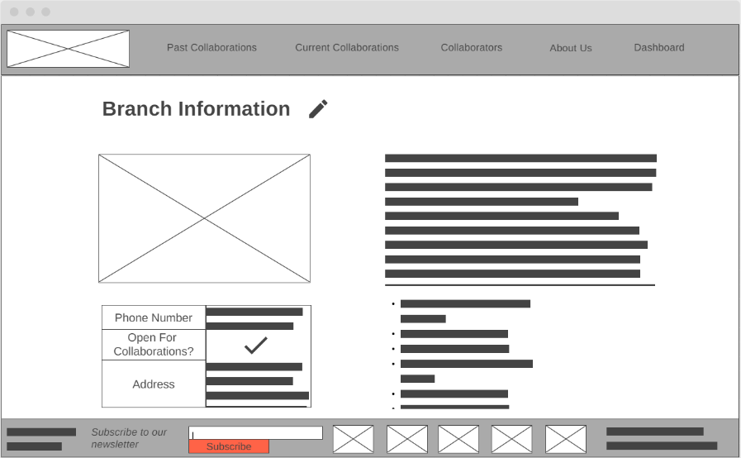

When clicked on that, they go to the Edit Page of the Branch Page

About Us Page

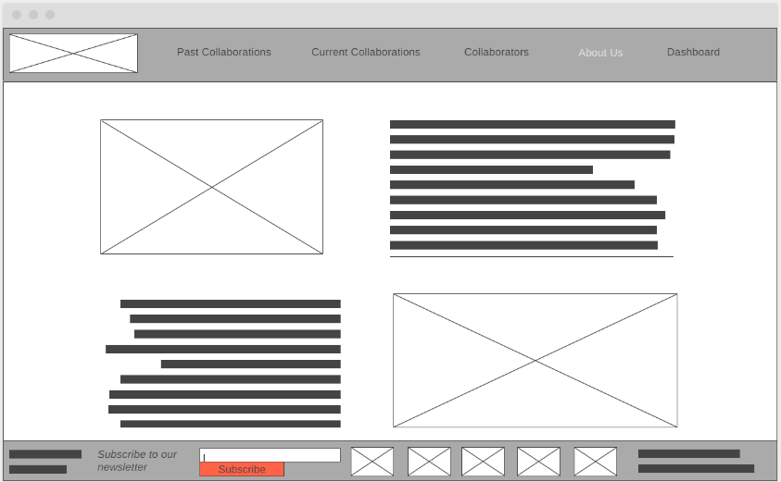

When Project Leads click on the Dashboard option, they get redirected to the available ChatRooms

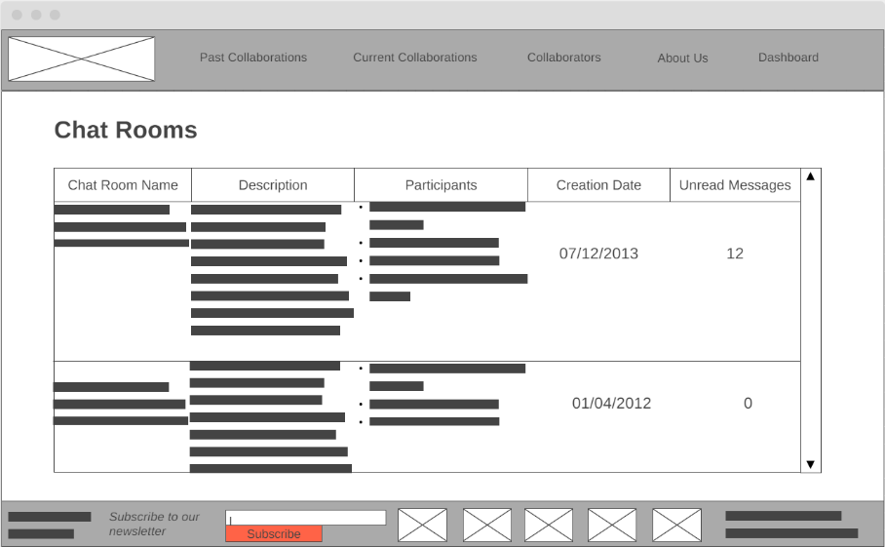

Clicking on one of them will bring up the individual ChatRoom

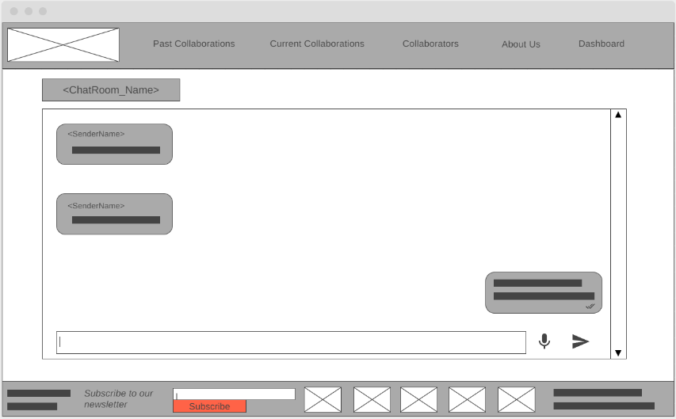

This is the view of the Branch Management’s Dashboard

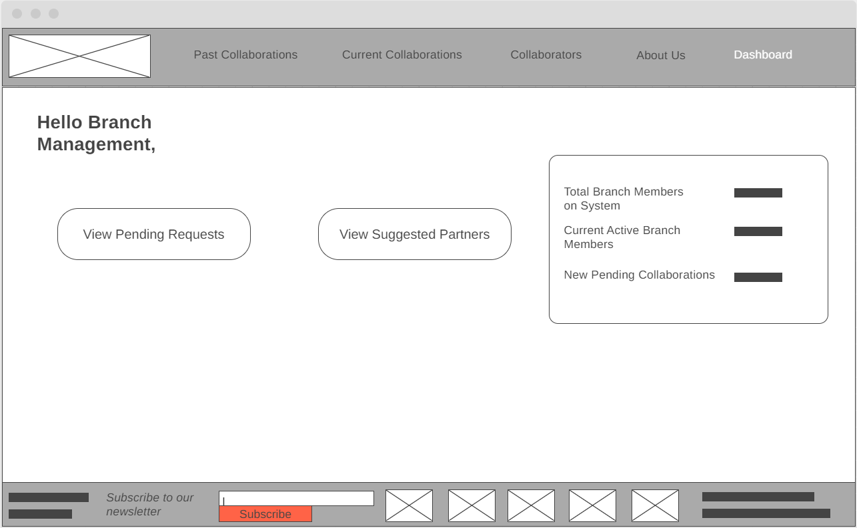

When the Pending Request Option is selected

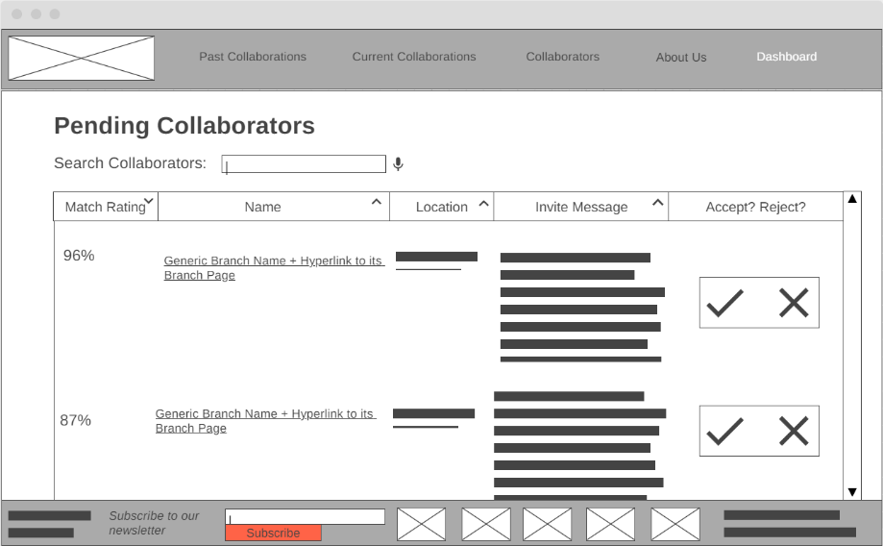

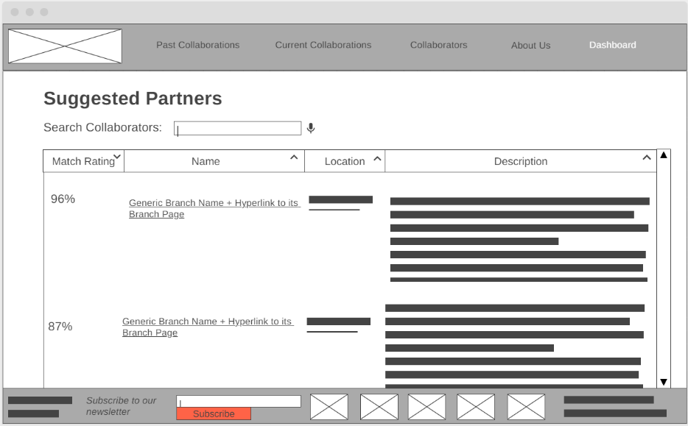When the Suggested Partners Option is Selected

We Assumed the Top Management is the Branch Management of the Headquarters, but they have the additional power to Respond to Invites to Collaborate for all the Branches. This is their Dashboard.

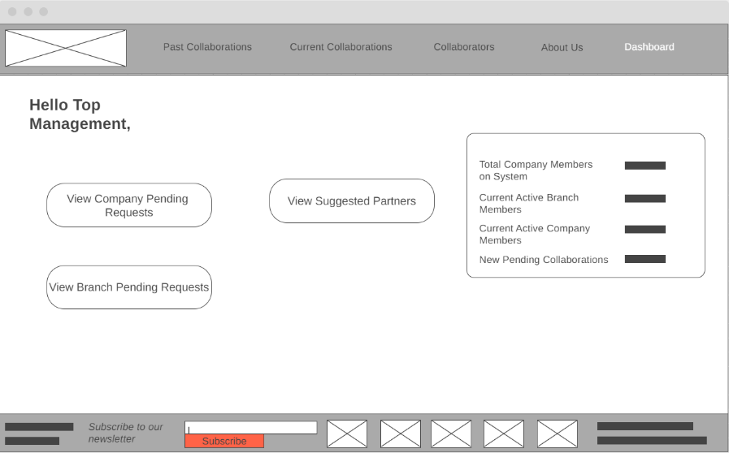

“View Branch Pending Requests” and “Suggest Partners” takes them to the Headquarters branch “Pending Requests” as depicted above for Branch Management.

View Company Pending requests are all the Pending requests for all the Branches under the Company.

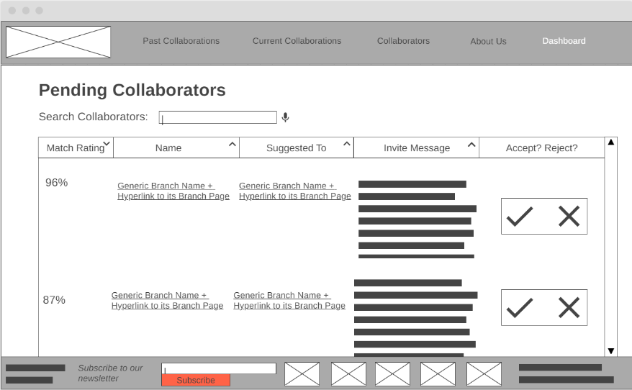

This is the External Relation’s Dashboard

Create Chatroom Leads us to this Page

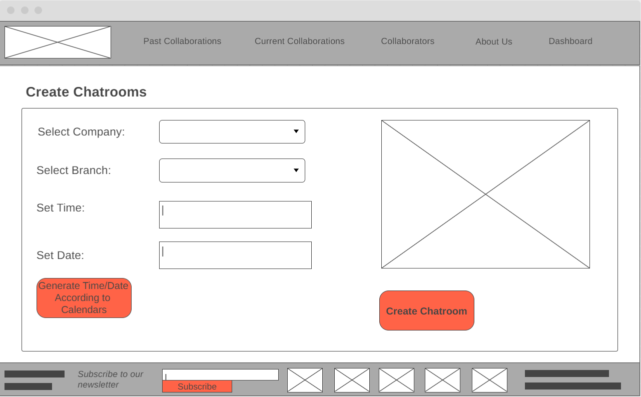

Initiate Collaborations Takes us to this page

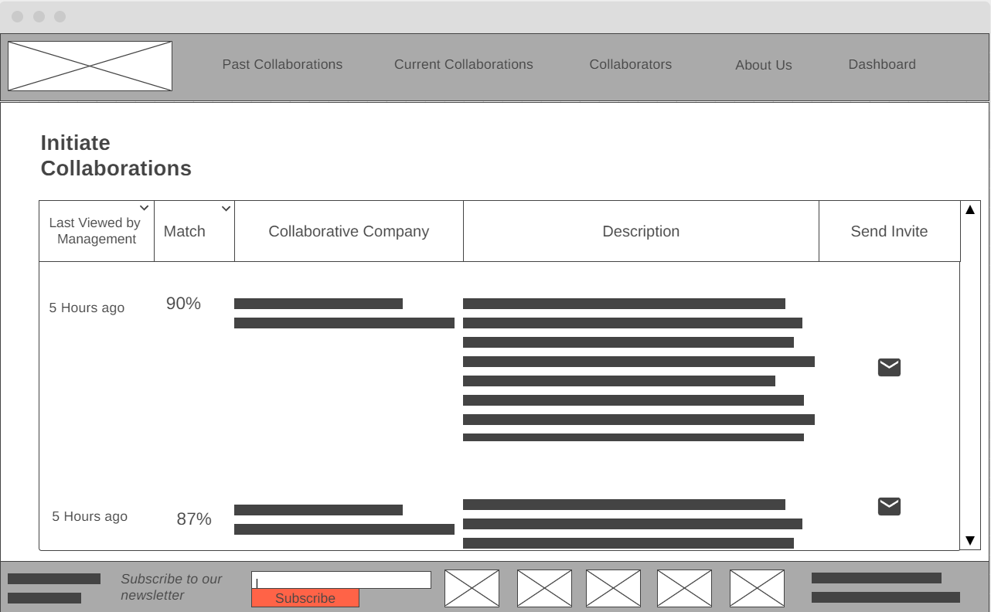

And once you select the Mail Icon for a collaborative company, we are taken to this page.

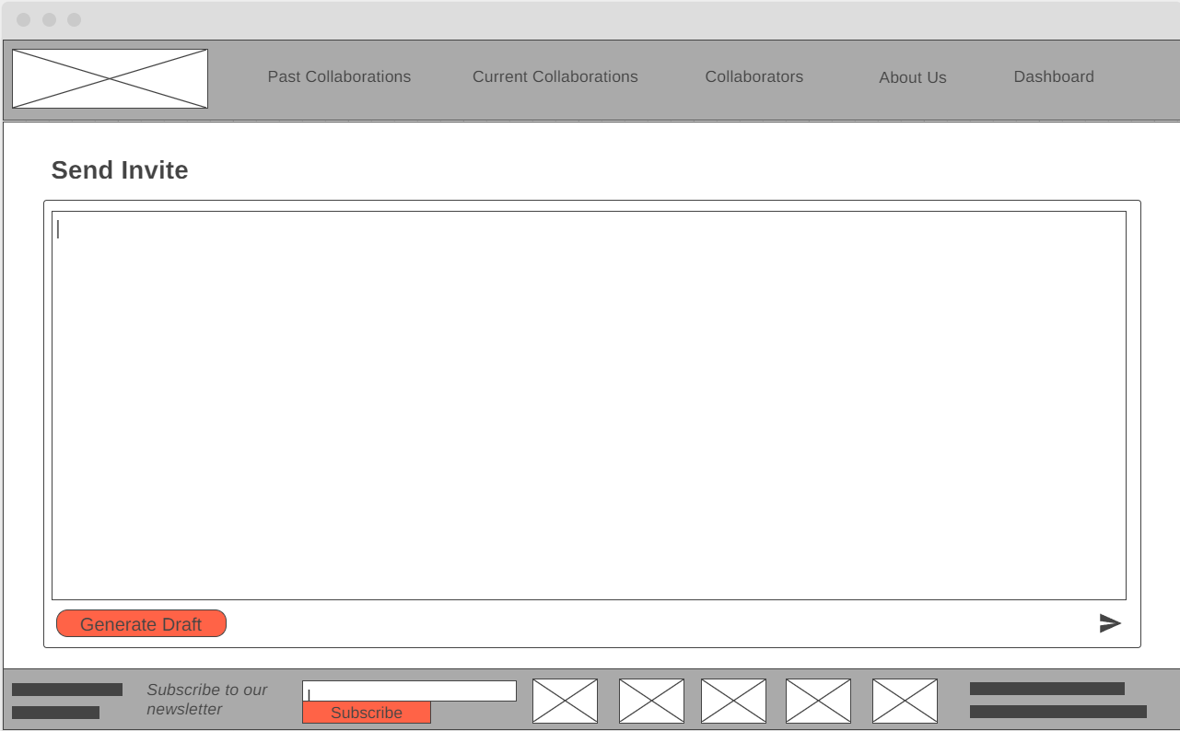

Finally, this would be the Admin Dashboard

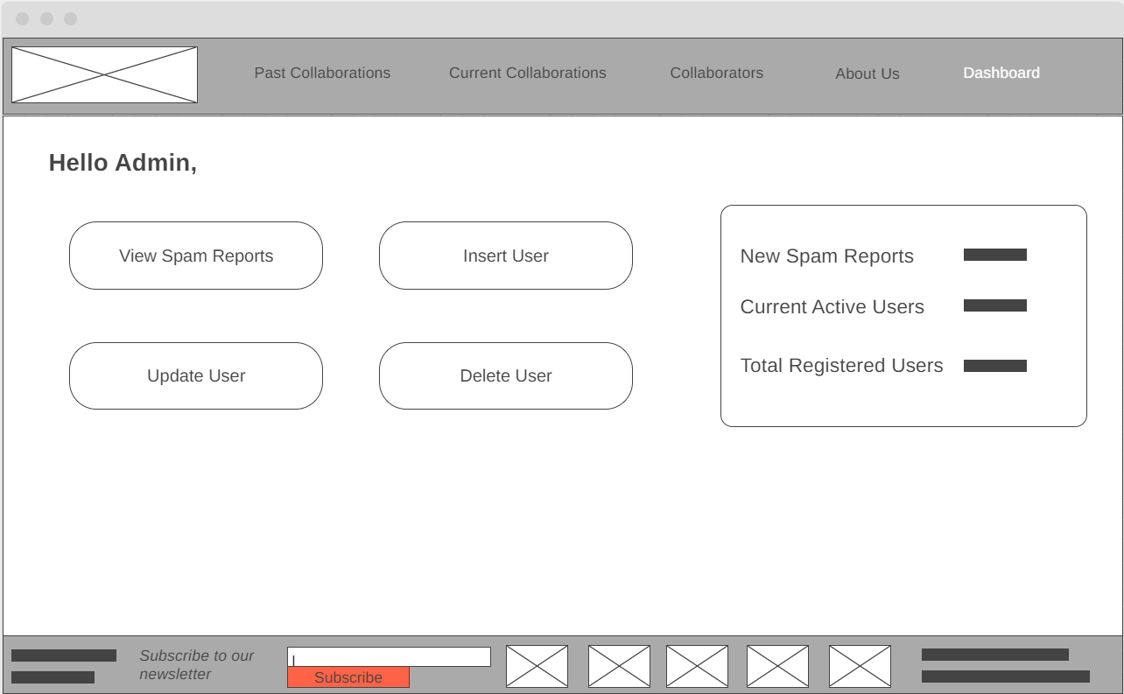

Insert User takes us here

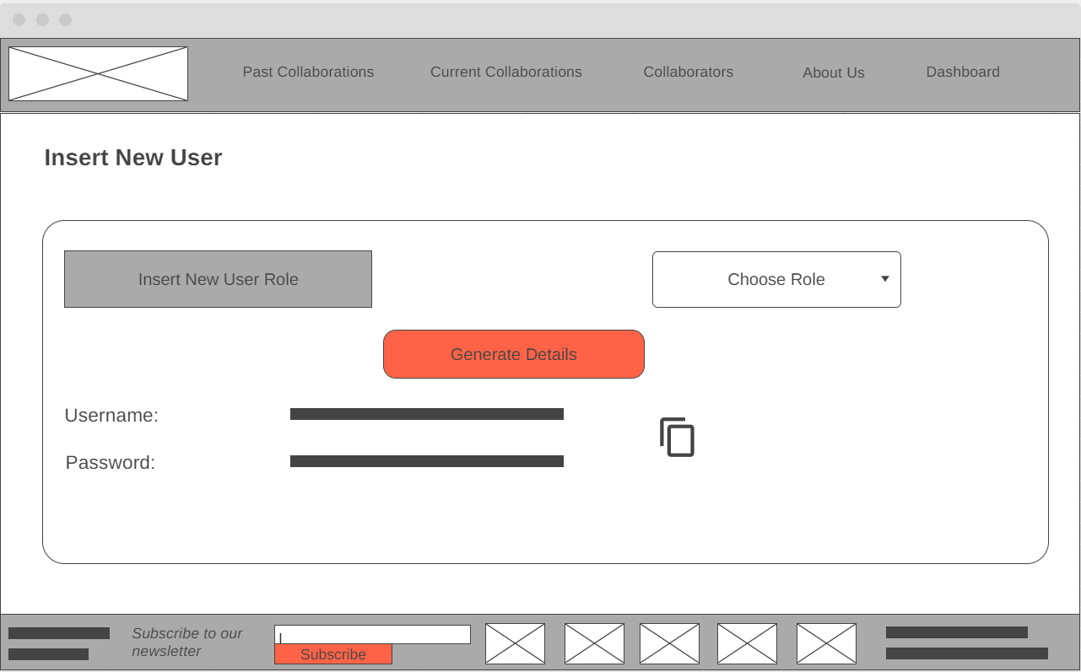

For security purposes we don’t allow users to come up with their own username and password, we use a Tokenlike system to prevent weak passwords and such, the admin will hand these two items off to the user which is why there is a copy button conveniently placed.

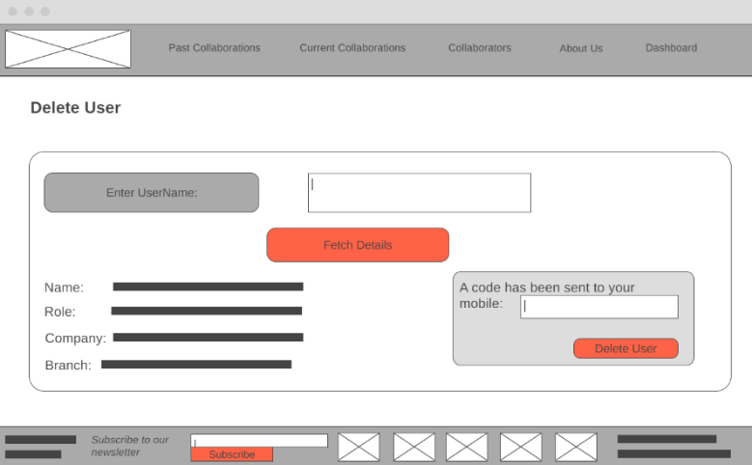Delete User option takes us here.

Once the Admin accesses this section, he/she will be texted a secret code that lasts 5 minutes, to prevent the hijacking of the admin role and manipulation.

Update User option takes us here.

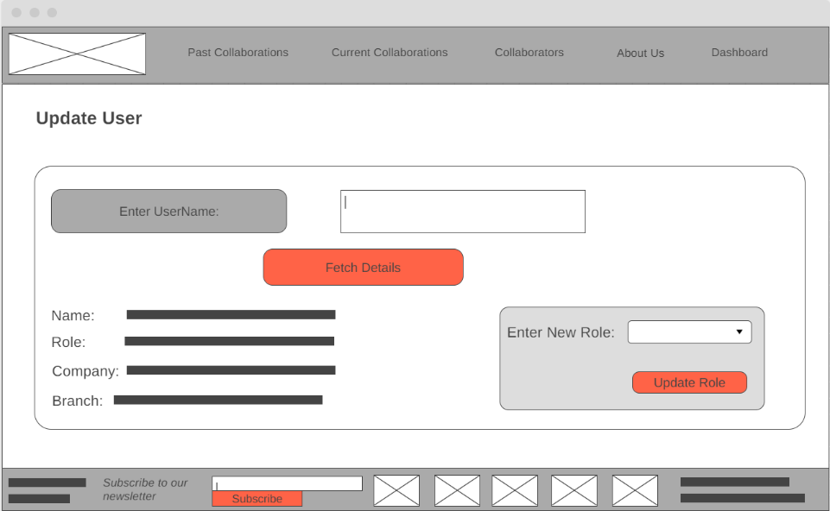

View Spam Reports option takes us here.

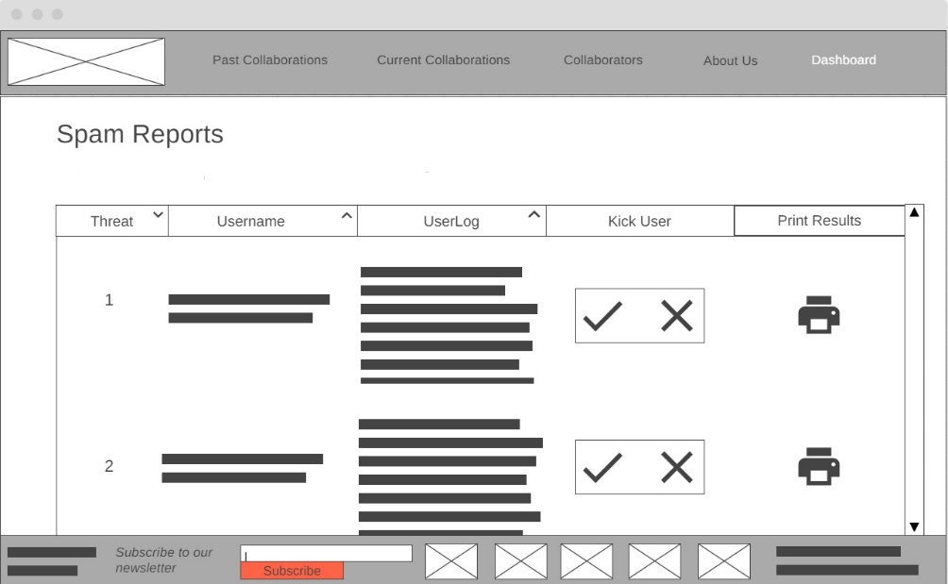

The Print option is there to coincide with the Filing system the admin maintains. Kick User option will take the admin directly to the delete page which will have the username already copied into the text box.

# Requirement Specification

**Software Requirements Specification**

For

**Centralized Collaboration Recording and Initiating System**

Prepared by Sahas Gunasekara

Freelancer

16/10/2021

*(Used Karl E. Wiegers Template, which we have permission to use, modify and distribute, all copyrights owned by Karl E. Wiegers)*

## Introduction

### Purpose

This SRS covers the entire scope of the Centralized Collaboration Recording and Initiating System, proposed by the National Engineers Association to extend its current system of recording collaborations between the Head Office and its Collaborators, to all the Branch’s and their Collaborators.

### Document Conventions

The Entire Document will be using Cambria font, size 12. Each Subsection will be highlighted by the Default Heading 3 Styling, and each main section will be highlighted by the Default Heading 2 Styling. Each requirement statement is to have its own priority and they cannot be quantifiably compared among each other.

### Intended Audience and Reading Suggestions

This document is intended to give a general but in-depth overview of the proposed system, to the developers, project managers and users. This SRS is organized according to main sections and subsections, with all material falling underneath them with a clear dichotomy of details. The Sections and Sub-sections can be viewed through the Table of Contents.

### Project Scope

The System is to be used to record and track all past and current collaborations between all levels of the National Engineers Association and Collaborative Companies. On extension the system also suggests Collaborators and allows both branches of the National Engineers Association and Collaborative Companies to initiate Collaborations and allow a rudimentary chat feature to discuss terms and conditions of Collaborations. Because the National Engineers Association and Collaborative Companies already use other complex communication systems such as MS Teams, Zoom and Conference Calling, we do not create complicated communication tools as they can use existing mechanisms to converse, reducing the Project Scope, and thus, its complexity.

### References

Ali, S. W., Ahmed, Q. A., & Shafi, I. (2018). Process to enhance the quality of software requirement specification document. *2018 International Conference on Engineering and Emerging Technologies (ICEET)*. Published. https://doi.org/10.1109/iceet1.2018.8338619

## Overall Description

### Product Perspective

This product can be defined as an extension of the existing system as there is already a system in place that tracks and records all Collaborations between the National Engineers Association Head office and its Collaborative Companies. We have extended this functionality to all the Branch Levels, and we have added the functionality to Initiate Collaborations between the branches with some additional supportive functionalities. Also supports the Physical Filing System the Admins maintain when kicking users from the existing system.

### Product Features

The main product features include Ability to View Current Collaborations, Ability to View Past Collaborations, Ability to View Collaborators, Ability to Initiate Collaborations, Ability to Respond to Collaborations Invites, Ability to Create Chatrooms about Collaborations. View Branch Pages, Edit Branch Pages. It should also allow Admins to Delete, Insert and Update Users and View Spam Reports. Discuss on Chatrooms.

### User Classes and Characteristics

Both members of the National Engineers Association and Collaborative Companies will interact through the system with distinct user roles.

1. User – Has the Ability to View Past Collaborations, View Current Collaborations, View Collaborators. There can be users of both National Engineers Association and Collaborative Companies.
2. Branch Management – Has the Ability to View Suggested Partners for Collaborations and View the Branch’s Pending Collaboration & Respond to them. Inherits the User’s functionalities.
3. Top Management – Has the Ability to View all the Branch’s under the Company’s Pending Collaborations and Respond to them. Inherits the Branch Management’s functionalities. (As the Top Management is the Branch Management of the Headquarters).
4. Admin – Has the Ability to View All User Roles, Update User Roles, Delete User Roles, Insert User Roles and View the Spam Reports. Inherits functionality of the Top Management. The only User Role that is exclusively employed by the National Engineers Association.
5. Editor – Has the Ability to Update the Company Branch Information. Inherits the Functionality of the User.
6. External Relations – Has the Ability to Initiate Collaborations by Sending Invites and can Create Chatrooms. Inherits the functionality of the Editors.
7. Project Lead – Has the Ability to Discuss with Collaborative Companies on the ChatRoom. Inherits the functionality of the User.

### Operating Environment

The System is to be initiated as a Web Application running on the AmazonWebServices (AWS) Linux servers (Amazon EC2 - Cloud Application). It will run all versions of Chromium-based browsers, all Safari browsers beyond Safari 10, and on all versions of Internet Explorer beyond Internet Explorer 10 (Including Microsoft Edge). The System will require to run coinciding with Google’s Speech to Text plugin, and Amazon Analytics plugin as they are supporting API’s used in the System. The System will also connect to the Amazon DynamoDB as its main database of storing data.

### Design and Implementation Constraints

The developers must ensure that Encryption always is maintained throughout the system as there is a possibility for corporate trade secrets to being revealed if accessed by unauthorized individuals. The System must interact only through the English (US) language. The developers must ensure that the application is able to be run on the 2GB Memory Allocation on the AWS Server and must accommodate at least 5000 concurrent users. Once the project is handed off to the National Engineers Association, the customer will be responsible for all routine maintenance and payment of supporting services.

### User Documentation

A series of supplementary videos will be uploaded to a filesharing platform allowing all stakeholders to view in .mp4 format which will detail the functionality and procedures of using the System.

### Assumptions and Dependencies

We have assumed the support for the Google Speech to Text API and Amazon Analytics will continue, the discontinuation of these features may render some parts of the System useless. If the Amazon Web Services suite, has a system wide failure, then the entire Collaboration system will be down as it based on the AWS Cloud technologies. We also use Google Calendars to Generate the Time/Date to open the chatrooms.

## System Features

### View Past Collaborations

#### Description and Priority

This is when all the users can View Past Collaborations. They can see all the Collaborations that have completed, the time they have taken, and they will be ordered in the reverse chronological order. They can also search for Collaborations using the search functionality. This is a high priority feature.

#### Stimulus/Response Sequences

Once landed on the Past Collaborations page, the user can use the vertical scroll bar to scroll through the Past Collaborations. The user can use the search function to find for a specific collaboration or use the voice icon to use Speech to Text to search for a specific collaboration.

#### Functional Requirements

USR-REQ-1: The System must keep record of all past collaborations and provide them to all requesting users.

USR-REQ-2: The System must implement a search functionality to search all past collaborations.

USR-REQ-3: The System must implement a Speech to Text Functionality to search for all Past Collaborations.

### View Ongoing Collaborations

#### Description and Priority

This is when all the users can View Ongoing Collaborations. They can see all the Collaborations that are going on, the time they have taken, the time taken ,and they will be ordered in the reverse chronological order. They can also search for Collaborations using the search functionality. This is a high priority feature.

#### Stimulus/Response Sequences

Once landed on the Ongoing Collaborations page, the user can use the vertical scroll bar to scroll through the Ongoing Collaborations. The user can use the search function to find for a specific collaboration or use the voice icon to use Speech to Text to search for a specific collaboration.

#### Functional Requirements

USR-REQ-4: The System must keep record of all ongoing collaborations and provide them to all requesting users.

USR-REQ-5: The System must implement a search functionality to search all ongoing collaborations.

USR-REQ-6: The System must implement a Speech to Text Functionality to search for all ongoing collaborations.

### View Collaborators

#### Description and Priority

This is when all the users can view collaborators. They can see all the Collaborators that are registered (both branches from the National Engineers Association and Collaborative Companies). This is a high priority feature.

#### Stimulus/Response Sequences

Once landed on the Collaborators page, the user can use the vertical scroll bar to scroll through the Collaborators. The user can use the search function to find for a specific Collaborator or use the voice icon to use Speech to Text to search for a specific Collaborator.

#### Functional Requirements

USR-REQ-7: The System must keep record of all Collaborators and provide them to all requesting users.

USR-REQ-8: The System must implement a search functionality to search all Collaborators.

USR-REQ-9: The System must implement a Speech to Text Functionality to search for all Collaborators.

### Initiate Collaborations

#### Description and Priority

This is when the External Relations Initiate Collaborations. They can see all the Suggested Collaborations, sorted by the Last Viewed by the Management, and Match Rating. This is a high priority feature.

#### 3.4.2 Stimulus/Response Sequences

Once Landed on the Initiate Collaborators page, the use can use the vertical scroll bar to scroll through the Collaborators. The user can use the search function to find for a specific collaboration or use the voice icon to use Speech to Text to search for a specific Collaboration. They can choose to send a Message, which will show up as a Pending Invite on the Branch Management’s Pending Collaborations page.

#### Functional Requirements

ExRe-REQ-1: The System must keep record of all suggested collaborations and provide them to all requesting users.

ExRe-REQ-2: The System must implement a search functionality to search all suggest collaborations.

ExRe-REQ-3: The System must implement a Speech to Text Functionality to search for all suggested collaborations.

ExRe-REQ-4: The System must generate a Match Rating for suggested collaborations.

ExRe-REQ-5: The System must allow the user to send a Message (Invite) to the suggested collaborations.

### Respond to Collaboration

#### 3.5.1 Description and Priority

This is when the Branch Management can respond to invites to Collaborate to their branch. They can view the Match Rating of the Pending Collaborations, Name and a hyperlink to the Branch Page. The Invite Message and whether to Accept or Reject. This is a High Priority Feature.

#### 3.5.2 Stimulus/Response Sequences

The Branch management can sort according to all columns on the table by clicking the arrow icon. They will be directed to the branch page if they click on the hyperlink. They can accept or reject clicking on the respective icons. Either option will remove the option from the pending collaborators table. They can search for a specific collaboration using the text box or using the Speech to Text function.

#### Functional Requirements

BaMa-REQ-1: The System must keep record of all the pending collaborations and provide them to all requesting users.

BaMa-REQ-2: The System must implement a search functionality to search all pending collaborations.

BaMa-REQ-3: The System must implement a Speech to Text Functionality to search all pending collaborations.

BaMA-REQ-4: The System must allow the users to choose whether to accept or reject pending collaborations.

### Create Chatrooms

#### 3.6.1 Description and Priority

This is when the External Relations can create chatrooms and add the accepted collaboration companies into the chatroom so that the Project Leads can discuss on it. This is a Medium Priority feature.

#### 3.6.2 Stimulus/Response Sequences

The External Relations can choose the company to add, select the branch (will only be displayed accepted collaboration branches), can manually set the time and date or generate time and date according to Calendars.

#### Functional Requirements

ExRe-REQ-6: The System must allow the user to select the Branch to add to the chatroom.

ExRe-REQ-7: The System must allow the user to select the Company to add to the chatroom.

ExRe-REQ-8: The System must allow the user to select the Time to add to the chatroom.

ExRe-REQ-9: The System must allow the user to select the Date to add to the chatroom.

ExRe-REQ-10: The System must generate a time/date according to the calendar of the occupants.

### Display all Chat room

#### 3.5.1 Description and Priority

This is when the Project Lead lands on the Chat Rooms page and then can view all the Chat Rooms that have been opened by the External Relations. This is a Medium Priority.

#### 3.7.2 Stimulus/Response Sequences

The user is displayed the ChatRoom name, the Description, Participants, Creation date and Unread Messages. When the user clicks on the Chat Room name, he is directed to the individual chat room page.

#### Functional Requirements

ProLea-REQ-1: The system must display all the available chatrooms to the user.

ProLea-REQ-2: The system must allow the user to scroll through the chatrooms using the vertical scroll bar.

ProLea-REQ-3: The system must direct the user to the individual chatroom when the user clicks on it.

ProLea-REQ-4: The System must display the count of unread messages to the user.

### Send/Receive Chats in the Chat room.

#### 3.8.1 Description and Priority

This is when the Project Lead chooses the Individual chatroom from the Chat Rooms page, he can view and send messages to and from from other participants in the group. This is a low-level priority.

#### 3.8.2 Stimulus/Response Sequences

The user is displayed all receiving messages, the user is displayed a text box to type messages in and the user is displayed a voice option if the user wants to send a voice message.

#### 3.7.3 Functional Requirements

ProLea-REQ-5: The system must display all the messages sent to and from the user in chronological order.

ProLea-REQ-6: The system must display two small ticks if the message was seen by the other participants.

ProLea-REQ-7: The system must send messages typed on the text box.

ProLea-REQ-8: The system must send a voice message if the record button was clicked on and audio was captured.

### Display Branch Information

#### 3.9.1 Description and Priority

This is when the User lands on an individual branch page. And can view all presented details of a branch. This is a Medium Priority.

#### 3.9.2 Stimulus/Response Sequence

The user is shown all the details that is displayed on the Branch. If the User is of Role Editor, then a small edit icon is displayed next to the Branch Name to edit the page. This is only if the Editor is employed by that respective Branch as well.

#### Functional Requirements

USR-REQ-10: The system must display the branch information when clicked on a branch name to all Users.

EDI-REQ-1: The system must display an edit icon if an editor views the branch information of the editors’ employee’s branch.

### Edit Branch Information

#### 3.10.1 Description and Priority

This is when the Editor clicks on the Edit icon next to their branch. They can edit the branch information. This is a low-level priority.

#### 3.10.2 Stimulus/Response Sequences

The editor is displayed text fields in which the editor can edit the information. The editor can upload an image of size less than 10MB as their company picture. The editor can choose the “Save” option to save the information. If the “Save” option is selected with some text fields left empty, the system will display a warning and not allow the changes to be saved.

#### Functional Requirements

EDI-REQ-2: The system must allow the editor to upload a new picture.

EDI-REQ-3: The system must allow the editor to change the fields

EDI-REQ-4: The System must allow the editor to save the changes.

EDI-REQ-5: The System must not allow the editor to save the changes if some items are left blank.

### Delete User

#### 3.11.1 Description and Priority

This is when the admin wants to delete a User from the system. This is a mid-level priority.

#### 

#### 3.11.2 Stimulus/Response Sequences

The admin lands on the Delete User page, a message will be sent to their mobile phone with a secret code, they will enter the username and fetch details. And they will enter the code in the section to enter it and click on delete user.

#### Functional Requirements

ADM-REQ-1: The System must allow the admin to delete Users.

### Insert New User

#### 3.12.1 Description and Priority

This is when the User wants to add a new user to them system.

#### 3.12.2 Stimulus/Response Sequences

The user lands on the Insert New User page, chooses a new user Role and then clicks on Generate Details.

#### Functional Requirements

ADM-REQ-2: The system must allow the user to choose the new role that the user is creating.

ADM-REQ-3: The system must generate two tokens for the UserName and Password.

### Viewing Spam Reports

#### 3.13.1 Description and Priority

This is when the user views all the Spam Reports that were generated by the system about Users who tried to create too many chatrooms. This is a low-level priority.

#### 3.13.2 Stimulus/Response Sequence

The user can sort the table by the Threat Rating, UserName and User Log. If the admin clicks on the Kick User cross option, then the spam entry is removed. If the admin clicks on the tick option, then the user will be taken to the delete user page with the user information already entered. Clicking on the Printer icon will generate a printable PDF to add to the existing Filing System. The user can scroll through the spam reports using the vertical scroll button.

#### Functional Requirements

ADM-REQ-4: The system must display all the Spam Reports to the Admin

ADM-REQ-5: The system must present the option to Kick the User

ADM-REQ-6: The system must be able to print the user report if needed.

### Update User

#### 3.14.1 Description and Priority

This is when the admin can update the User Roles of users. This is a low-level priority.

#### 3.14.2 Stimulus/Response Sequence

The admin lands on this page, enters the Username, clicks on fetch details to get the details of the user, and then chooses a new role, and clicks on update role.

#### Functional Requirements

ADM-REQ-7: The system must allow the admin to update the user roles of the users.

### Login Page

#### 3.15.1 Description and Priority

This is the first landing page that all users, meet which is the login page.

#### 3.14.2 Stimulus/Response Sequence

The user lands on this page, and enters the login and password, if successfully logged in, then the user will get moved to the Past Collaborations page.

#### 3.15.2 Functional Requirements

LOG-REQ1: The System must have a login page to prevent unauthorized users from accessing the system.

## External Interface Requirements

### User Interfaces



Throughout the entire system we will have the same Header and Footer style allowing the User to be displayed certain important information constantly in the footer, and navigation paths in the top. The entire system will use materialistically flat icons and all the icons to be used are intuitive and easy to understand. There is also additionally space for sponsor images located in the footer as well.

More in-depth UI images have already been included in a separate report under the section of Wireframes.

### Hardware Interfaces

Because this is a Web Application that is hosted on a Cloud Computing platform, the hardware interface details are abstracted. This is beneficial for the National Engineers Association since they do not need to focus on maintaining physical servers as well as the responsibility has been transferred to Amazon Web Services.

### Software Interfaces

The outward software interfaces include the Google API of Speech to Text, which we can use to send an MP3 and receive a string type, this must be done through the HTTPS, to ensure secure transferring of sensitive material. We also additionally use the Amazon Web Suite’s Analytics for predictive search results. For data storage when it comes to populating the tables for things such as Collaborations, we use DynamoDB. When saving information in the tables most of the tables will solely contain the String type. However, the exception would be the table storing the Branch Information which would store the string and “BLOB” type information since we would want the table to store the Images as well. This too can be done using the inhouse API that we receive when we use this software. Data such as usernames and passwords would be stores in a String Table on DynamoDB as well however we will be using one-way encryption to store the information.

### Communications Interfaces

We use HTTPS (Hypertext Transfer Protocol Secure) for all transfers of packets between the end users to ensure that we are having end to end encryption. This is a combination of the HTTP (Hypertext Transfer Protocol) along with SSL (Secure Socket Layer)/ TLS (Transfer Layer Security) protocols. When uploading the Image for a branch we would be using FTP (File Transfer Protocol). This too will be handled by AWS; however we have detailed the process in which it will be handled.

## Non-Functional Requirements

### Performance Requirements

1. Each page of the system must load within 3 seconds for an internet speed of 5Mbps.
2. Searching functionality of the system must fetch results within 0.5 seconds.
3. Database queries should return results within 0.1 seconds.

### Security Requirements

1. The system must remain resilient in times of DDOS attacks.
2. The system must always ensure the integrity of data.
3. The system will use abstraction where possible to prevent direct manipulation of services.
4. The system will not allow access to a web browser that it cannot authenticate.

### Reliability Requirements

1. The system will have a Maximum Tolerable Downtime of 10 hours per month.
2. The system must be able to reboot within 1 hour of Downtime.

### Functionality Requirements

1. The system shall display large datasets in the format of tables for intuitive digestion of information.
2. The system should be followed clean UX design to ensure intuitive functionality.

# References

Atzeni, P., Cheung, D., & Ram, S. (Eds.). (2012). Conceptual Modeling. *Lecture Notes in Computer Science*. Published. https://doi.org/10.1007/978-3-642-34002-4

FRANCH, X., GRAU, G., MAYOL, E., QUER, C., AYALA, C., CARES, C., NAVARRETE, F., HAYA, M., & BOTELLA, P. (2007). SYSTEMATIC CONSTRUCTION OF i* STRATEGIC DEPENDENCY MODELS FOR SOCIO-TECHNICAL SYSTEMS. *International Journal of Software Engineering and Knowledge Engineering*, *17*(01), 79–106. https://doi.org/10.1142/s0218194007003148